**Exercises**

To test whether a table has been modified correctly as you do these exercises, you can write and run an appropriate SELECT statement. Or, when you’re using MySQL Workbench, you can right-click on a table name in the Object Browser window and select the Select Rows - Limit 1000 command to display the data for the table in a Result tab. To refresh the data in this tab after modifying the table data, click the Refresh button in the toolbar at the top of the tab.

1. Write an **INSERT** statement that adds this row to the Terms table:
   1. terms_id: 6
   2. terms_description: Net due 120 days
   3. terms_due_days: 120
   4. Use MySQL Workbench to review the column definitions for the Terms table, and include a column list with the required columns in the INSERT statement.

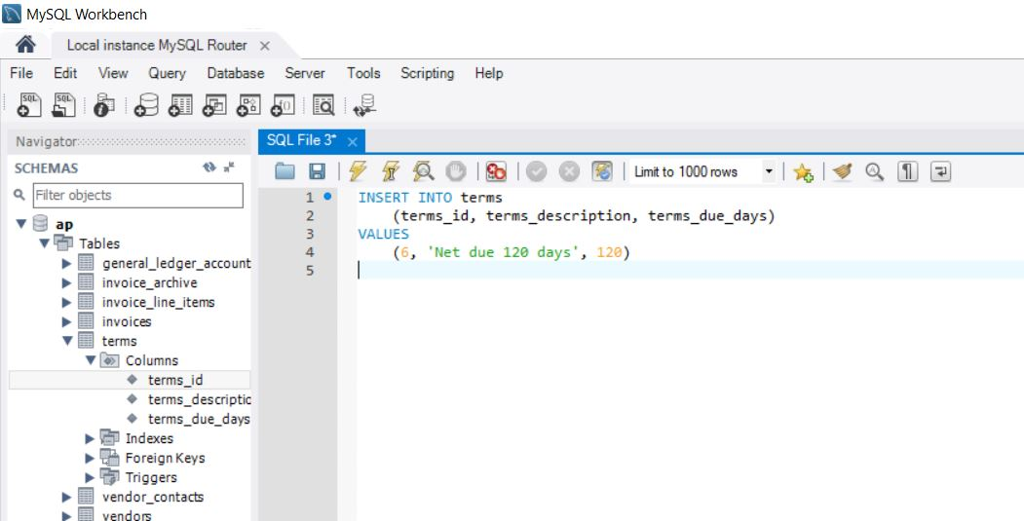

1. Write an **UPDATE** statement that modifies the row you just added to the **Terms** table. This statement should change the *terms_description* column to “Net due 125 days”, and it should change the *terms_due_days* column to 125.

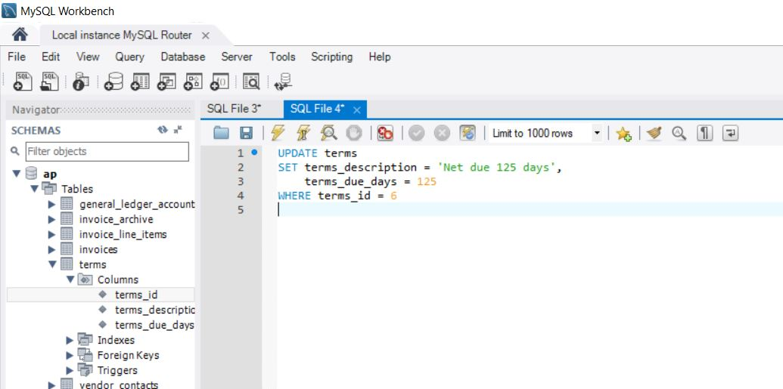

1. Write a **DELETE** statement that deletes the row you added to the **Terms** table in exercise 1.

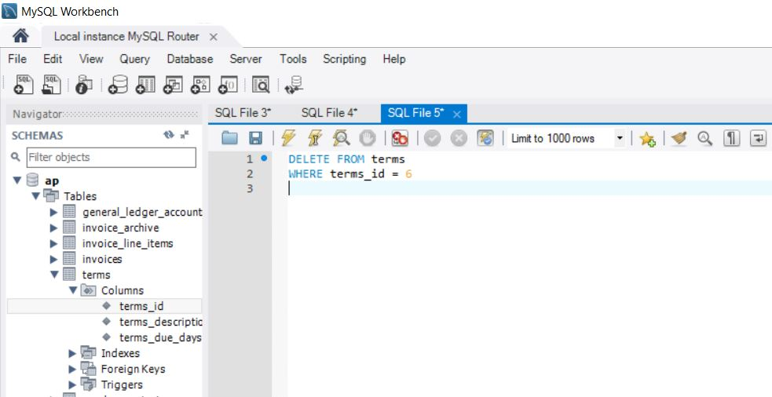

1. Write an **INSERT** statement that adds this row to the **Invoices** table:
   * 1. invoice_id: The next automatically generated ID
     2. vendor_id: 32
     3. invoice_number: AZ-014-027
     4. invoice_date: 8/1/2014
     5. invoice_total: $434.58
     6. payment_total: $0.00
     7. credit_total: $0.00
     8. terms_id: 2
     9. invoice_due_date: 8/31/2014
     10. payment_date: null
   1. Write this statement without using a column list.

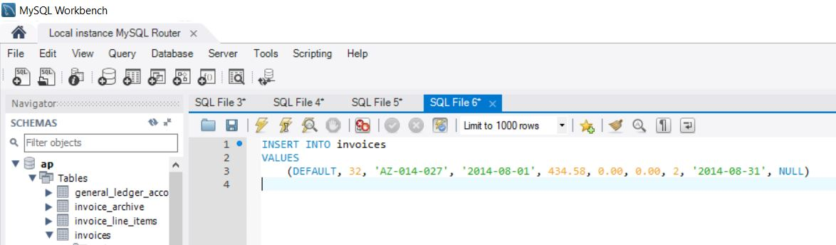

1. Write an **INSERT** statement that adds these rows to the **Invoice_Line_Items** table:
   * 1. invoice_sequence: 1 2
     2. Account_number: 160 527
     3. line_item_amount: $180.23 $254.35
     4. line_item_description: Hard drive Exchange Server Update
   1. Set the *invoice_id* column of these two rows to the invoice ID that was generated by MySQL for the invoice you added in exercise 4.

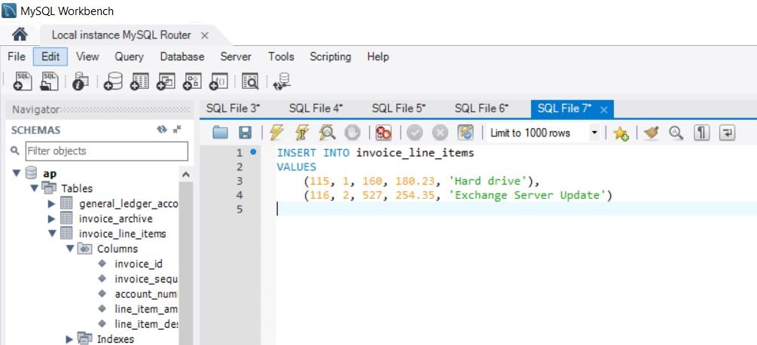

1. Write an **UPDATE** statement that modifies the invoice you added in exercise 4. This statement should change the *credit_total* column so it’s 10% of the *invoice_total* column and it should change the *payment_total column* so the sum of the *payment_total* and *credit_total*columns are equal to the *invoice_total*column.

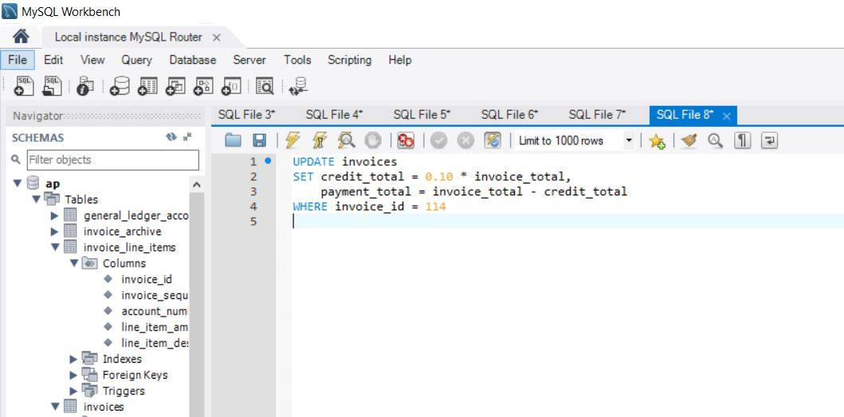

1. Write an **UPDATE** statement that modifies the **Vendors** table. Change the *default_account_number* column to 403 for the vendor with an ID of 44.

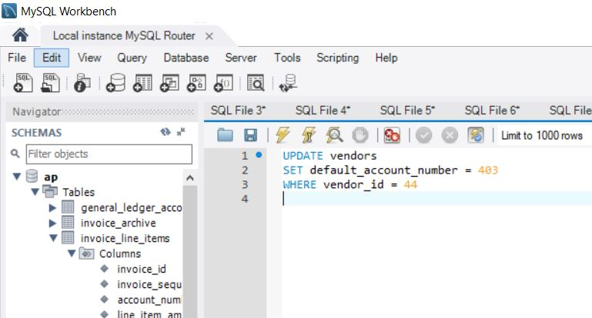

1. Write an **UPDATE** statement that modifies the **Invoices** table. Change the *terms_id* column to 2 for each invoice that’s for a vendor with a *default_terms_id* of 2.

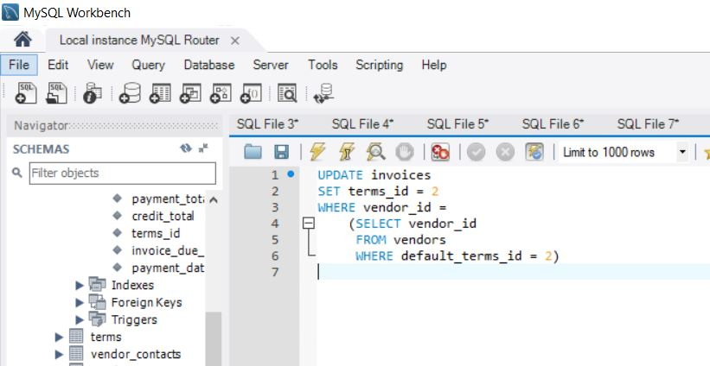

1. Write a **DELETE** statement that deletes the row that you added to the **Invoices** table in exercise 4. When you execute this statement, it will produce an error since the invoice has related rows in the **Invoice_Line_Items** table. To fix that, precede the **DELETE** statement with another **DELETE** statement that deletes the line items for this invoice. (Remember that to code two or more statements in a script, you must end each statement with a semicolon.)

